 MOTOR ACCIDENT REPORT FORM

We are so sorry you had an accident. Tell us about it and we will get your life back on track. It is important that this form be properly completed, signed and dated to avoid any delays.

- About you (Policyholder)
Full Name | Address | Occupation
Mobile # | Home # | Business #
Email | Contact preference Email □ Telephone □ | Policy #

Were you the driver? Yes □ No □ If yes, go to section 3. If no, please provide driver’s details in section 2.

- About your driver
Full Name | Address | Occupation
Mobile # | Home # | Business #
Email | Contact preference Email □ Telephone □ | Date of birth (dd/mm/yyyy)
Driver’s licence # | What is the relationship between you and the driver?  Spouse □ Child □ Parent □ Friend □ Employee □ Other _____________

- About your vehicle
Year | Make | Model | Registration Plate No. | Chassis No.

Is there a mortgagee/hire purchase agreement in respect of your vehicle? Yes □ No □

If yes, please state the Finance Company’s name and branch (if applicable):

How many persons were in your vehicle (including driver)?

Was the driver operating the vehicle with your consent? Yes □ No □ If no, please explain

- Details about what happened
What date did it happen? (dd/mm/yyyy) | What time did it happen? __________a.m. / p.m.
Where did it happen? | In what direction was your vehicle heading?
In what direction was the other vehicle heading? | Did you report the accident to the police? Yes □ No □  If yes, please state name of police station:_____________________
Condition of road Good □ Fair □ Poor □ | Weather Wet □ Dry □
Street lighting Yes □ No □ | Visibility Good □ Fair □ Poor □

Do you consider yourself responsible for the accident and why? Yes □ No □

Please describe in detail what happened:

____________________________________________________________________________________________________________

____________________________________________________________________________________________________________

____________________________________________________________________________________________________________

____________________________________________________________________________________________________________

____________________________________________________________________________________________________________

____________________________________________________________________________________________________________

___________________________________________________________________________________________________________

____________________________________________________________________________________________________________

____________________________________________________________________________________________________________

____________________________________________________________________________________________________________

____________________________________________________________________________________________________________

Please provide a sketch diagram of the accident below:

- About the damage to your vehicle

Is there any damage to your vehicle? Yes □ No □ If no, please move to section 6.

Is your vehicle drivable? Yes □ No □

Describe the damage to your vehicle:

Please submit damage estimate & photographs if available. You may also circle the area of damage on the last page of this form

- About the other vehicle or property involved in the accident

Motor Vehicle
Particulars | Vehicle 1 | Vehicle 2 | Vehicle 3

Full name of owner

Owner’s address

Full name of driver

Driver’s licence no.

Vehicle registration no.

Make & model of vehicle

Name of insurance company

Description of damage

Property (Other than Motor Vehicle)
Particulars | Property 1 | Property 2 | Property 3

Owner of property

Location of property

Description of damage

- About injuries in your vehicle
Name | Address | Relationship with Insured/Driver | Age | Occupation | Nature of Injury

- About injuries in other vehicle/s
Name | Address | Nature of Injury

- About witness

Did anyone witness the accident? Yes □ No □ If yes, please provide details below:
Name | Address | Telephone No./Email Address

- Declaration and Signature/s

I/We hereby declare that to the best of my/our knowledge and belief that the information I/we have provided is correct and request you to deal on my/our behalf with any claims which may arise out of the accident in accordance with the terms and conditions of the Policy.

I/We authorize you and your attorneys-at-law on my behalf to make such admissions and settlements and give such consents as you consider necessary for the disposal of such claims and any litigation arising therefrom.

__________________________________ __________________________________

DATE SIGNATURE OF DRIVER

__________________________________ __________________________________

DATE SIGNATURE OFINSURED(S)

Circle the section of your vehicle that was damaged

Front
Left  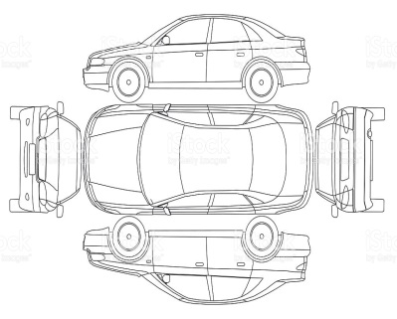  Rear  Right | 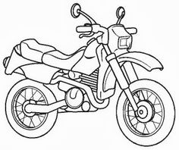  Right  Left
Left  Front  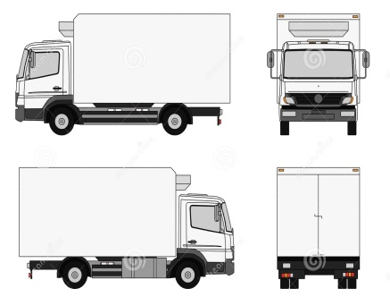  Right  Rear | 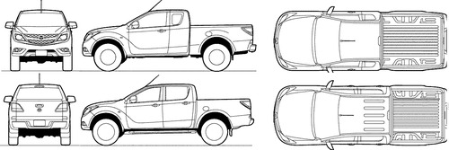  Front  Rear  Right  Left

THANK YOU & NEXT STEPS

Please tear off and keep this section for future reference

- Thank you for completing this form. You will be contacted within the next 4 working days regarding the status of your claim.
- Please send this form to your nearest BCIC Branch, Broker or Agent or you may email to claimsedocs@bcicbarbados.com
- If you are claiming for damage to your own vehicle, please submit an estimate as early as possible.
- On receipt of your estimate, we will send one of our approved motor surveyors to view your vehicle, provided that you have cover.
- If you have comprehensive cover and intend to claim for damage to your vehicle, an excess (or deductible) will be applicable. This is an amount you pay out of pocket towards the damage.
- If you receive any letter, claim, writ, summons or other document in relation to an accident, you must send it immediately to your nearest BCIC Branch, Broker or Agent. Do not respond or reply to any such document.
- If you have any questions or need to update any information regarding your claim, please contact us at claimsedocs@bcicbarbados.com or (246) 621-7340 or you may reach out to your Broker or Agent.

We’re here for you!

Our Motto: We focus on the CUSTOMER, not the claim



